
RAMAIAH
Institute of Technology
USN | 1 | M | S

(Autonomous Institute, Affiliated to VTU)
(Approved by AICTE, New Delhi & Govt. of Karnataka) Accredited by NBA & NAAC with ‘A’ Grade

SEMESTER END EXAMINATIONS – JANUARY 2020

Program | : | B.E. : Common to all Programs | Semester | : | I
Course Name | : | Engineering Mathematics - I | Max. Marks | : | 100
Course Code | : | MA11/MAT101 | Duration | : | 3 Hrs
Instructions to the Candidates:
- Answer one full question from each unit.

 |  | UNIT- I
1. | a) | Define homogeneous function for two variables. | CO1 | (02)
 | b) | Find the length of perpendicular from pole to the tangent for the curve 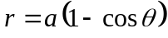 at 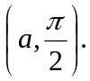 | CO1 | (04)
 | c) | If 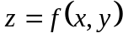 where 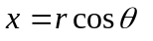and 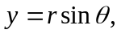then show that  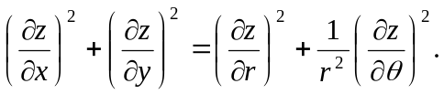 | CO1 | (07)
 | d) | Find the Jacobian of  w.r.t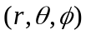. | CO1 | (07)
2. | a) | State the condition for the functions and are in terms of and are functionally dependent. | CO1 | (02)
 | b) | If 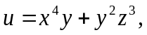 where 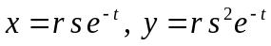 and 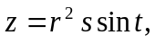then find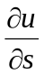at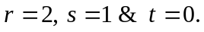 | CO1 | (04)
 | c) | Find the angle of intersection of pairs of curves:  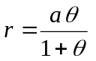and 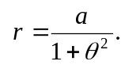 | CO1 | (07)
 | d) | If 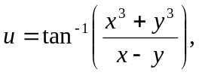then show that  (i) 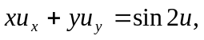 (ii)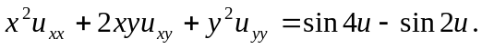 | CO1 | (07)
 |  | UNIT- II
3. | a) | Write the expression to find the volume of the solid for a polar curve, when rotated about the initial line and the line 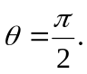 | CO2 | (02)
 | b) | Evaluate :  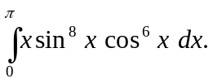 | CO2 | (04)
 | c) | Trace the curve 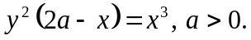 | CO2 | (07)
 | d) | Find the surface area of the solid obtained when cycloid 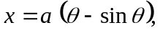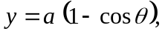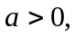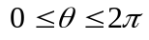 is rotated about its base. | CO2 | (07)
4. | a) | State any two properties while tracing cartesian curves. | CO2 | (02)
 | b) | Find the perimeter of the asteroid 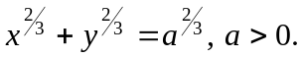 | CO2 | (04)
 | c) | Prove that:  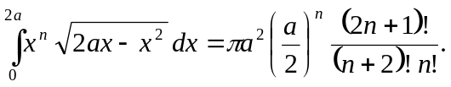 | CO2 | (07)
 | d) | Find the volume of the solid generated by revolution of the cardioid 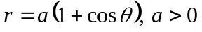about the initial line. | CO2 | (07)
 |  | UNIT- III
5. | a) | Define velocity and acceleration of a vector point function of single variable. | CO3 | (02)
 | b) | Find 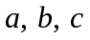such that  is conservative . | CO3 | (04)
 | c) | Prove the vector identity 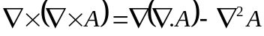. | CO3 | (07)
 | d) | Find the directional derivative of the function 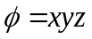 along the direction of the normal to the surface 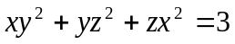 at the point 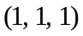. | CO3 | (07)
6. | a) | Give the physical meaning of curl of a vector field. | CO3 | (02)
 | b) | At any point on the curve 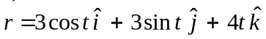, find normal vector. | CO3 | (04)
 | c) | Find the values of 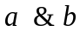 so that the surfaces 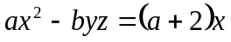 and 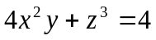 may intersect orthogonally at the point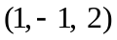. | CO3 | (07)
 | d) | Find the value of the constant ‘’ such that is solenoidal. For this value of ‘’ show that 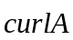 is also solenoidal. | CO3 | (07)
 |  | UNIT- IV
7. | a) | Write the transformation equations from cartesian to cylindrical polar coordinates. | CO4 | (02)
 | b) | Evaluate:  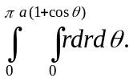 | CO4 | (04)
 | c) | Evaluate:  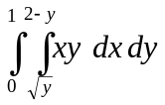by changing the order of integration. | CO4 | (07)
 | d) | Find the volume tetrahedron bounded by the planes  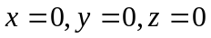 and 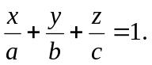 | CO4 | (07)
8. | a) | With the help of a neat diagram, mark the region of integration of the double integral  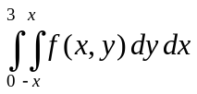. | CO4 | (02)
 | b) | Evaluate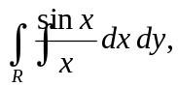where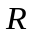is the triangle in the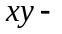plane bounded by the axis, the line 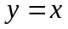 and the line 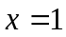. | CO4 | (04)
 | c) | Evaluate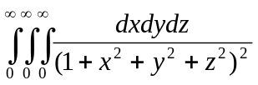using spherical polar coordinates. | CO4 | (07)
 | d) | Evaluate 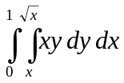 by changing the order of integration. | CO4 | (07)
 |  | UNIT- V
9. | a) | Define work done in moving a particle along a path C. | CO5 | (02)
 | b) | Using Green’s theorem evaluate 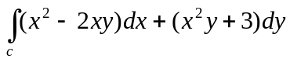 around the boundary of the region defined by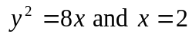. | CO5 | (04)
 | c) | Evaluate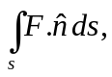where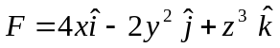and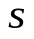is the surface bounded by 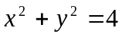and the planes 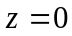 and 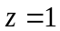using Gauss divergence theorem. | CO5 | (07)
 | d) | Evaluate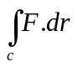, where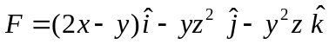and is the boundary of the upper half of the sphere 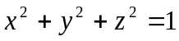using Stoke’s theorem. | CO5 | (07)
10. | a) | State Stoke’s theorem. | CO5 | (02)
 | b) | Find the total work done in moving particle by a force field 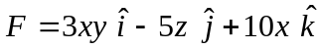along the curve 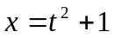, 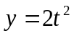and 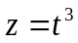from 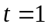to 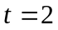. | CO5 | (04)
 | c) | State and prove Green’s theorem in a plane. | CO5 | (07)
 | d) | Using Gauss divergence theorem evaluatewhere  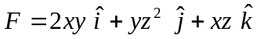andis the rectangular parallelepiped bounded by | CO5 | (07)

****************

